

**Semester One Examination, 2020**

**Question/Answer Booklet**

**MATHEMATICS**

**METHODS**

**ATAR Year 12**

**Section Two:**

**Calculator-assumed**

Student Name: **SOLUTIONS**

Please circle your teacher’s name

**Teacher: Miss Long Miss Rowden Ms Stone**

**Time allowed for this paper**

Reading time before commencing work: 10 minutes

Working time for paper: 100 minutes

**Materials required/recommended for this paper**

***To be provided by the supervisor***

Number of additional

answer booklets used

(if applicable):

This Question/Answer Booklet

Formula Sheet (retained from Section One)

***To be provided by the candidate***

Standard items: pens (blue/black preferred), pencils (including coloured), sharpener, correction fluid/tape, eraser, ruler, highlighters

Special items: drawing instruments, templates, notes on two unfolded sheets of A4 paper, and up to three calculators approved for use in this examination

**Important note to candidates**

No other items may be taken into the examination room. It is **your** responsibility to ensure that you do not have any unauthorised material. If you have any unauthorised material with you, hand it to the supervisor **before** reading any further.

**Structure of this paper**

|  |  |  |  |  |  |
| --- | --- | --- | --- | --- | --- |
| Section | Number of questions available | Number of questions to be answered | Suggested working time (minutes) | Marks available | Percentage of examination |
| Section One:  Calculator free | 8 | 8 | 50 | 52 | 35 |
| Section Two:  Calculator-assumed | 13 | 13 | 100 | 97 | 65 |
|  |  |  |  | **Total** | 100 |

**Instructions to candidates**

1. The rules for the conduct of the ATAR course examinations are detailed in the *Year 12 Information Handbook 2020*. Sitting this examination implies that you agree to abide by these rules.
2. Write your answers in this Question/Answer booklet.
3. You must be careful to confine your answers to the specific questions asked and to follow any instructions that are specific to a particular question.
4. Supplementary pages for the use planning/continuing your answer to a question have been provided at the end of the Question/Answer booklet. If you use these pages to continue an answer, indicate at the original answer where the answer is continued, i.e. give the page number.
5. Show all your working clearly. Your working should be in sufficient detail to allow your answers to be checked readily and for marks to be awarded for reasoning. Incorrect answers given without supporting reasoning cannot be allocated any marks. For any question or part question worth more than two marks, valid working or justification is required to receive full marks. If you repeat any question, ensure that you cancel the answer you do not wish to have marked.
6. It is recommended that you do not use pencil, except in diagrams.
7. The Formula sheet is not to be handed in with your Question/Answer booklet.

**Section Two: Calculator-assumed 65% (97 Marks)**

This section has thirteen (13) questions. Answer **all** questions. Write your answers in the spaces

provided.

Supplementary pages for the use of planning/continuing your answer to a question have been provided at the end of this Question/Answer booklet. If you use these pages to continue an answer, indicate at the original answer where the answer is continued, i.e. give the page number.

Working time: 100 minutes.

Question 9 (4 marks)

The graphs of $y=\cos^{2}\left(x+\frac{π}{6}\right)$ and $y=\frac{3}{4}$ are shown below. Determine the exact area of the shaded region they enclose.

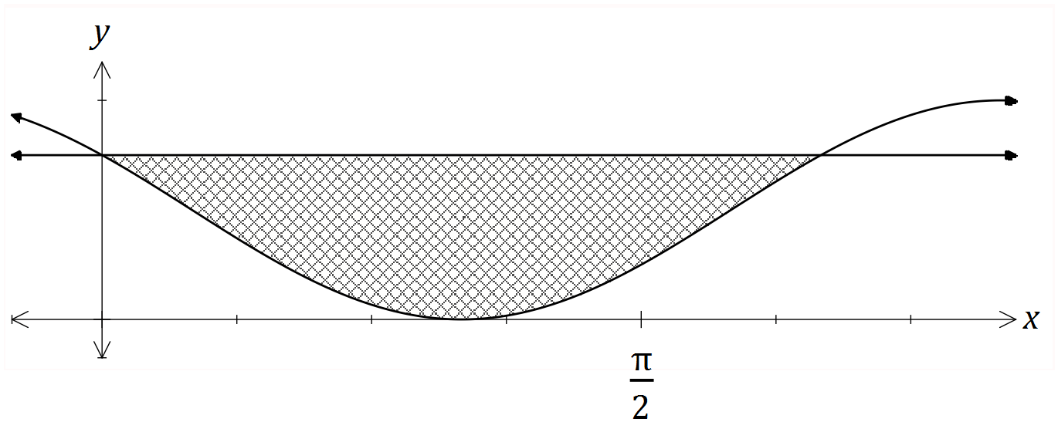

|  |
| --- |
| **Solution** |
| $$\cos^{2}\left(x+\frac{π}{6}\right)=\frac{3}{4}⇒x=0,\frac{2π}{3} \\ A=\int_{0}^{2π/3}{\frac{3}{4}-\cos^{2}\left(x+\frac{π}{6}\right)} dx \\ A=\frac{π}{6}+\frac{\sqrt{3}}{4} \text{sq units}$$ |
| **Specific behaviours** |
| ✓ solves intersection of functions  ✓ writes required integral  ✓ uses exact values throughout  ✓ evaluates integral exactly |

Question 10 (8 marks)

A small body moving in a straight line has displacement $x$ cm from the origin at time $t$ seconds given by

$$x=8\cos\left(0.5t-2\right)+1.5, 0≤t≤12.$$

(a) Use derivatives to justify that the maximum displacement of the body occurs when $t=4$.

(4 marks)

|  |
| --- |
| **Solution** |
| $$\frac{dx}{dt}=-4\sin\left(0.5t-2\right) \\ t=4⇒\frac{dx}{dt}=-4\sin\left(0\right)=0$$ Hence when $t=4, x$ has a stationary point. $$\frac{d^{2}x}{dt^{2}}=-2\cos\left(0.5t-2\right) \\ t=4⇒\frac{d^{2}x}{dt^{2}}=-2\cos\left(0\right)=-2$$ Since second derivative is negative, the stationary point is a maximum, and so the body has a maximum displacement when $t=4$. |
| **Specific behaviours** |
| ✓ first derivative  ✓ indicates stationary point at required time  ✓ value of second derivative at required time  ✓ statement that justifies maximum |

(b) Determine the time(s) when the velocity of the body is not changing. (2 marks)

|  |
| --- |
| **Solution** |
| $$a=\frac{d^{2}x}{dt^{2}}=-2\cos\left(0.5t-2\right)$$ $$a=0⇒\cos\left(0.5t-2\right)=0$$ $$t=-π+4, π+4≈0.858, 7.142 \text{seconds}$$ |
| **Specific behaviours** |
| ✓ indicates acceleration/second derivative must be zero  ✓ states exact (or approximate) times in interval |

(c) Express the acceleration of the body in terms of its displacement $x$. (2 marks)

|  |
| --- |
| **Solution** |
| $$a=-2\cos\left(0.5t-2\right) \\ =-0.25\left(8\cos\left(0.5t-2\right)\right) \\ =-0.25\left(x-1.5\right)$$ |
| **Specific behaviours** |
| ✓ factors out $-0.25$ ✓ correct expression |

Question 11 (8 marks)

The voltage, $V$ volts, supplied by a battery $t$ hours after timing began is given by

$$V=8.95e^{-0.265t}$$

(a) Determine

|  |
| --- |
| **Solution** |
| $$V\left(0\right)=8.95 \text{V}$$ |
| **Specific behaviours** |
| ✓ correct value |

(i) the initial voltage. (1 mark)

|  |
| --- |
| **Solution** |
| $$V\left(3\right)=4.04 \text{V}$$ |
| **Specific behaviours** |
| ✓ correct value |

(ii) the voltage after $3$ hours. (1 mark)

(iii) the time taken for the voltage to reach $0.03$ volts. (1 mark)

|  |
| --- |
| **Solution** |
| $$t=21.5 \text{h}$$ |
| **Specific behaviours** |
| ✓ correct value |

(b) Show that $\begin{matrix}dV \\ \overline{dt}\end{matrix}=aV$ and state the value of the constant $a$. (2 marks)

|  |
| --- |
| **Solution** |
| $$\frac{dV}{dt}=-0.265\left(8.95e^{-0.265}\right) \\ =aV$$ $$a=-0.265$$ |
| **Specific behaviours** |
| ✓ correct derivative  ✓ value of $a$ |

(c) Determine the rate of change of voltage $3$ hours after timing began. (1 mark)

|  |
| --- |
| **Solution** |
| $$\dot{V}=-0.265×4.04=-1.07 \text{V/h}$$ |
| **Specific behaviours** |
| ✓ correct rate |

(d) Determine the time at which the voltage is decreasing at $5\%$ of its initial rate of decrease.

(2 marks)

|  |
| --- |
| **Solution** |
| $$\dot{V}∝V⇒e^{-0.265t}=0.05$$ $$t=11.3 \text{h}$$ |
| **Specific behaviours** |
| ✓ indicates suitable method  ✓ correct time |

Question 12 (7 marks)

The function $f$ is defined as $f\left(x\right)=\begin{matrix}5e^{0.125x} \\ \overline{ x }\end{matrix} , x>0$, and the graph of $y=f(x)$ is shown below.

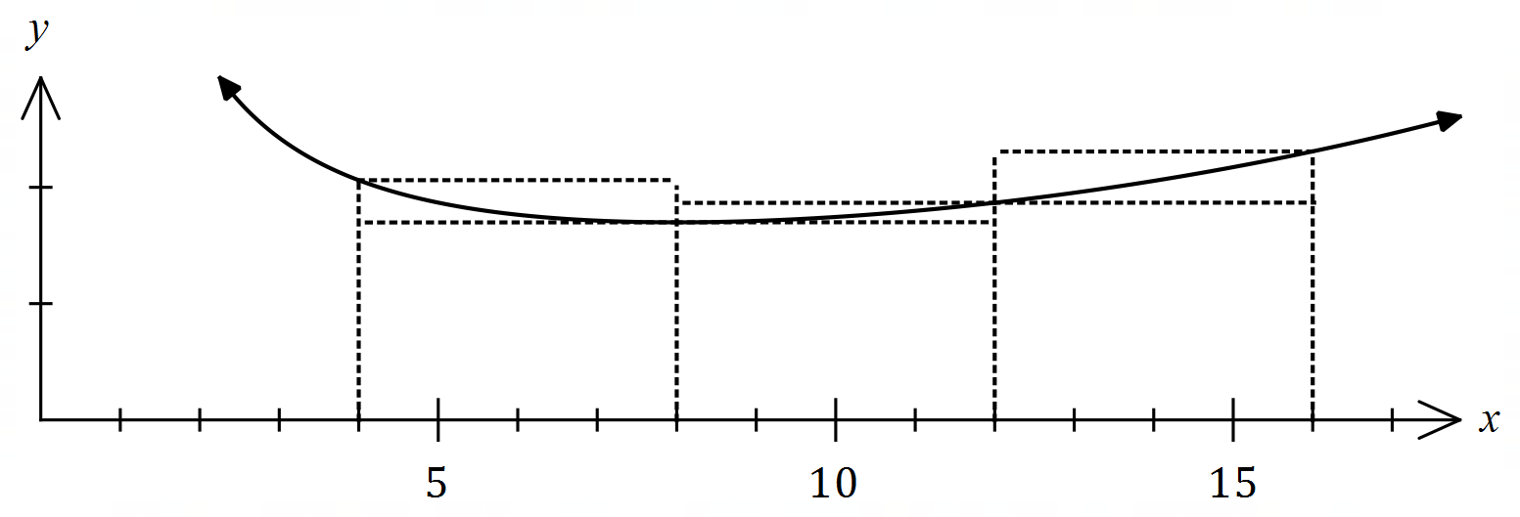

(a) Complete the missing values in the table below, rounding to $2$ decimal places.

(1 mark)

|  |
| --- |
| **Solution** |
| See table |
| **Specific behaviours** |
| ✓ both correct |

|  |  |  |  |  |
| --- | --- | --- | --- | --- |
|  |  |  |  |  |
|  |  |  |  |  |

(b) Use the areas of the rectangles shown on the graph to determine an under- and over-estimate for $\int_{4}^{16}{\underset{ }{\overset{ }{f(x)}}}dx$. (3 marks)

|  |
| --- |
| **Solution** |
| $$U=4\left(1.70+1.70+1.87\right)=4×5.27=21.08$$ $$O=4\left(2.06+1.87+2.31\right)=4×6.24=24.96$$ |
| **Specific behaviours** |
| ✓ indicates $δx=4$ ✓ under-estimate  ✓ over-estimate |

(c) Use your answers to part (b) to obtain an estimate for $\int_{4}^{16}{\underset{ }{\overset{ }{f(x)}}}dx$. (1 mark)

|  |
| --- |
| **Solution** |
| $$E=\left(21.08+24.96\right)÷2≈23.0$$ |
| **Specific behaviours** |
| ✓ correct mean |

(d) State whether your estimate in part (c) is too large or too small and suggest a modification to the numerical method employed to obtain a more accurate estimate. (2 marks)

|  |
| --- |
| **Solution** |
| Estimate is too large ( $f(x)$ is concave upwards).  Better estimate can be found using a larger number of thinner rectangles. |
| **Specific behaviours** |
| ✓ states too big  ✓ indicates modification to improve estimate |

**Question 13 (7 marks)**

Functions $f$ and $g$ are such that

$$f\left(4\right)=2, f^{'}\left(x\right)=18{\left(3x-10\right)}^{-2}$$

$$g\left(-4\right)=2, g^{'}\left(x\right)=18{\left(3x+10\right)}^{-2}$$

(a) Determine $f(6)$. (3 marks)

|  |
| --- |
| **Solution** |
| $$f\left(6\right)=f\left(4\right)+\int_{4}^{6}{18{\left(3x-10\right)}^{-2}}dx \\ =2+{\left[\frac{-6}{3x-10}\right]}_{4}^{6} \\ =2+\left(-\frac{3}{4}-(-3)\right) \\ =\frac{17}{4}=4\frac{1}{4}$$ |
| **Specific behaviours** |
| ✓ integrates rate of change  ✓ determines change  ✓ correct value |

(b) Use the increments formula to determine an approximation for $g(-3.98)$. (3 marks)

|  |
| --- |
| **Solution** |
| $$x=-4, δx=0.02$$ $$δy≈\frac{18}{{\left(3x+10\right)}^{2}}×δx \\ ≈\frac{18}{4}×0.02≈0.09$$ $$g\left(-3.95\right)≈2+0.09≈2.09$$ |
| **Specific behaviours** |
| ✓ values of $x$ and $δx$ ✓ use of increments formula  ✓ correct approximation |

(c) Briefly discuss whether using the information given about $f$ and the increments formula would yield a reasonable approximation for $f(6)$. (1 mark)

|  |
| --- |
| **Solution** |
| No, approximation wouldn't - the change $δx=2$ is not a small change. *(NB Yields $f\left(6\right)≈11$)* |
| **Specific behaviours** |
| ✓ states no with reason |

Question 14 (9 marks)

A small body leaves point $P$ and travels in a straight line for $24$ seconds until it reaches point $Q$. The velocity $v$ m/s of the body is shown in the graph below for $0≤t≤24$ seconds.

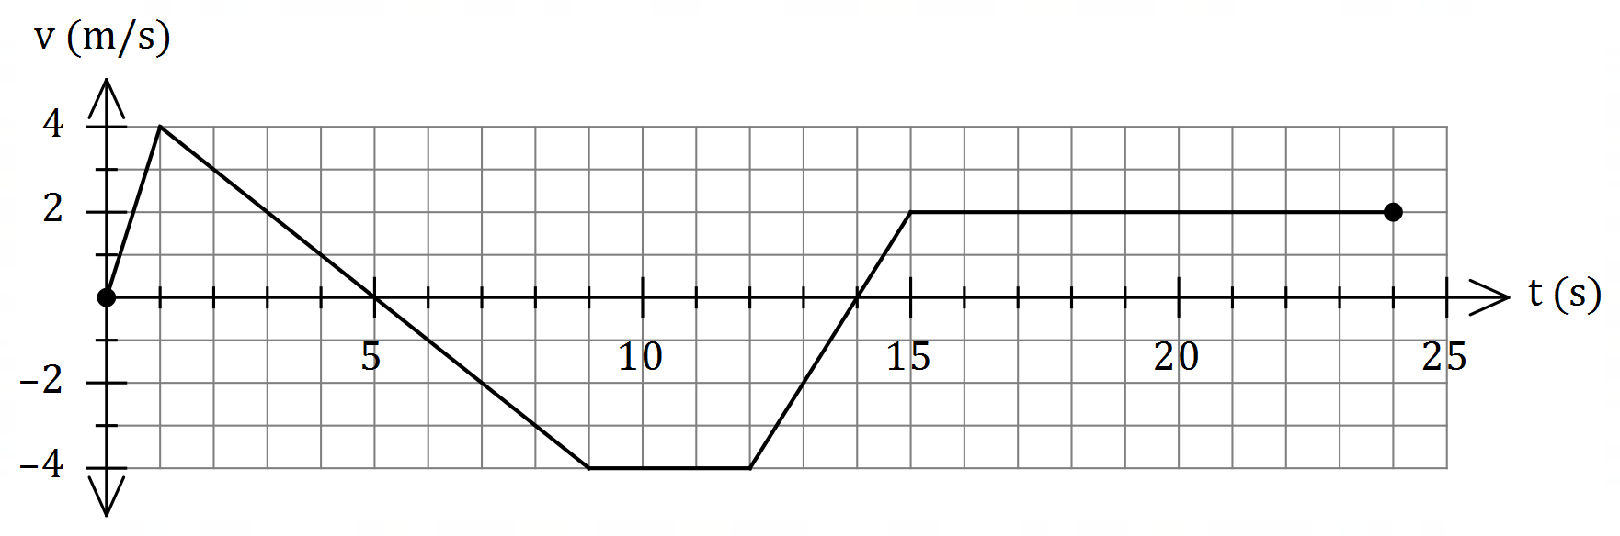

(a) Use the graph to evaluate $\int_{0}^{5}{\underset{ }{\overset{ }{v}}}dt$ and interpret your answer with reference to the motion of the small body. (3 marks)

|  |
| --- |
| **Solution** |
| $$\int_{0}^{5}{v}dt=\frac{1}{2}×5×4=10 \text{m}$$ The change in displacement of the body during the first $5$ seconds is $10$ m.  OR  The body has moved $10$ m to the right of $P$ during first $5$ seconds. |
| **Specific behaviours** |
| ✓ value of integral  ✓ interprets as change in displacement  ✓ includes specific time and distance with units in interpretation |

(b) Determine an expression, in terms of $t$, for the displacement of the body relative to $P$ during the interval $1≤t≤9$. (3 marks)

|  |
| --- |
| **Solution** |
| $$v=5-t⇒x=\int{5-t}dt=5t-0.5t^{2}+c$$ $$t=1,x=2⇒2=5\left(1\right)-{0.5\left(1\right)}^{2}+c⇒c=-2.5$$ $$x=5t-{0.5t}^{2}-2.5, 1≤t≤9$$ |
| **Specific behaviours** |
| ✓ expression for $v$ ✓ expression for $x$ with constant $c$ ✓ correct expression for $x$ |

(c) Determine the time(s) at which the body was at point $P$ for $0<t≤24$.

(3 marks)

|  |
| --- |
| **Solution** |
| $$x\left(9\right)=10+\frac{1}{2}×4×\left(-4\right)=2$$ $$2-4\left(t-9\right)=0⇒t=9.5$$ $$x\left(15\right)=-13$$ $$-13+2\left(t-15\right)=0⇒t=21.5$$ Body at point $P$ when $t=9.5$ s and $t=21.5$ s. |
| **Specific behaviours** |
| ✓ indicates appropriate method using areas  ✓ one correct time  ✓ two correct times |

Question 15 (9 marks)

A curve has equation $y=\left(x-3\right)e^{2x}$.

(a) Show that the curve has only one stationary point and use an algebraic method to determine its nature. (3 marks)

|  |
| --- |
| **Solution** |
| $$y^{'}=2xe^{2x}-5e^{2x} \\ =e^{2x}\left(2x-5\right)$$ For stationary point, require $y^{'}=0$ and since $e^{2x}≠0$ then $x=2.5$- there is only one stationary point. $$y^{''}=4xe^{2x}-8e^{2x}$$ $$x=2.5⇒y^{''}=2e^{5}$$ Hence stationary point is a local minimum. |
| **Specific behaviours** |
| ✓ first derivative  ✓ uses factored form to justify one stationary point  ✓ indicates minimum using derivatives (sign or 2nd) |

(b) Justify that the curve has a point of inflection when $x=2$. (4 marks)

|  |
| --- |
| **Alternative Solution** |
| $$y^{''}=4e^{2x}\left(x-2\right) \\ y^{''}(2)=4e^{2(2)}\left(2-2\right)=0$$ $$y^{'''}=4e^{2x}\left(2x-3\right) \\ y'''\left(2\right)=4e^{4}$$ Hence point of inflection as $f^{''}\left(2\right)=0$ and $f^{'''}\left(2\right)≠0$. |
| **Specific behaviours** |
| ✓ second derivative  ✓ shows second derivative is zero  ✓ calculates third derivative  ✓ explains justification |

|  |
| --- |
| **Solution** |
| $$y^{''}=4e^{2x}\left(x-2\right) \\ y^{''}\left(1.9\right)=4e^{2\left(1.9\right)}\left(1.9-2\right)≈-18 \\ y^{''}(2)=4e^{2(2)}\left(2-2\right)=0 \\ y^{''}\left(2.1\right)=4e^{2\left(2.1\right)}\left(2.1-2\right)≈27$$ Hence point of inflection as concavity changes from $-$ ve to $+$ ve as $x$ increases through $x=2$. |
| **Specific behaviours** |
| ✓ second derivative  ✓ shows second derivative is zero  ✓ calculates second derivative either side  ✓ explains justification |

(c) Sketch the curve on the axes below.

(2 marks)

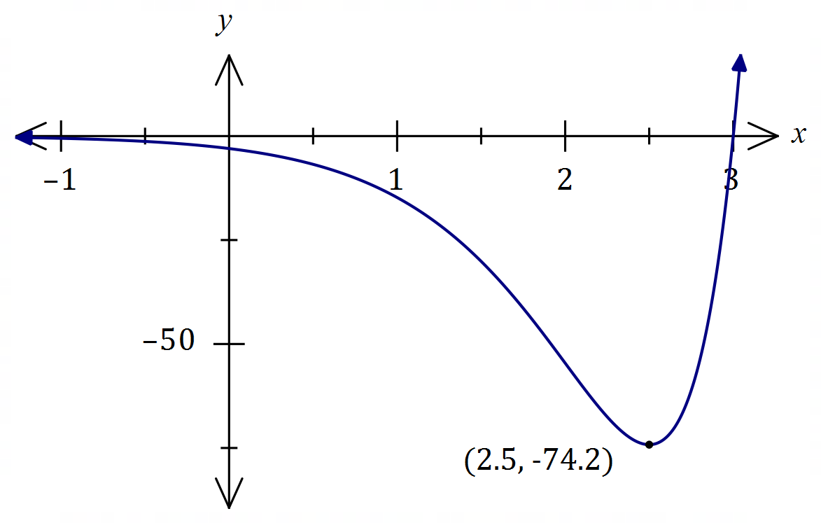

|  |
| --- |
| **Solution** |
| See graph |
| **Specific behaviours** |
| ✓ minimum, $y$-intercept  ✓ correct shape |

Question 16 (8 marks)

Let $P(a, b)$ be a point in the first quadrant that lies on the curve $y=5-x^{2}$ and $A$ be the area of the triangle formed by the tangent to the curve at $P$ and the coordinate axes.

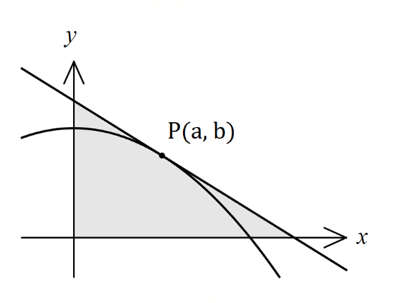

(a) Show that $A=\begin{matrix}{\left(a^{2}+5\right)}^{2} \\ \overline{ 4a }\end{matrix}$.

(4 marks)

|  |
| --- |
| **Solution** |
| Gradient at $P$: $$\frac{dy}{dx}=-2x⇒m_{P}=-2a$$ Equation of tangent: $$y-b=-2a(x-a) \\ y-\left(5-a^{2}\right)=-2ax+2a^{2} \\ y=-2ax+a^{2}+5$$ Axes intercepts: $$y=0⇒x=\frac{a^{2}+5}{2a}, x=0⇒y=a^{2}+5$$ Area: $$A=\frac{1}{2}\left(\frac{a^{2}+5}{2a}\right)\left(a^{2}+5\right)=\frac{{\left(a^{2}+5\right)}^{2}}{4a}$$ |
| **Specific behaviours** |
| ✓ in terms of $a$ and $m_{P}$ ✓ equation of tangent in terms of $a, x, y$ (any form)  ✓ axes intercepts  ✓ indicates area of right triangle |

(b) Use calculus to determine the coordinates of $P$ that minimise $A$.

(4 marks)

|  |
| --- |
| **Solution** |
| Hence $P\left(\frac{\sqrt{15}}{3},\frac{10}{3}\right)≈P(1.291, 3.333)$ |
| **Specific behaviours** |
| ✓ first derivative  ✓ solves for $a$ ✓ indicates check for minimum (graph, sign or second derivative test)  ✓ correct coordinates, exact or at least $2$ dp |

Question 17 (8 marks)

(a) The cost of producing *x* items of a product is given by . Each item is sold for $24.90.

1. Determine the profit equation.

(1 mark)

|  |
| --- |
| **Solution** |
|  |
| **Specific behaviours** |
| ✓ correct profit equation (does not need to be simplified) |

Use differentiation to determine

1. the profit associated with the sale of the 1001st item.

(3 marks)

|  |
| --- |
| **Solution** |
|  |
| **Specific behaviours** |
| ✓ derives *P*  ✓ substitutes *x* = 1000  ✓ determines the value of *P* |

(b) Use the increments formula to determine the percentage change in the radius of a cone if the height remains constant and *V* increase by 3%.

(4 marks)

|  |
| --- |
| **Solution** |
|  |
| **Specific behaviours** |
| ✓ derives *V*  ✓ values of $δV$ ✓ use of increments formula  ✓ correct approximation |

Question 18 (9 marks)

(a) The rule of the graph below is of the form $y=\log_{2}\left(x-b\right)+c$.

(2 marks)

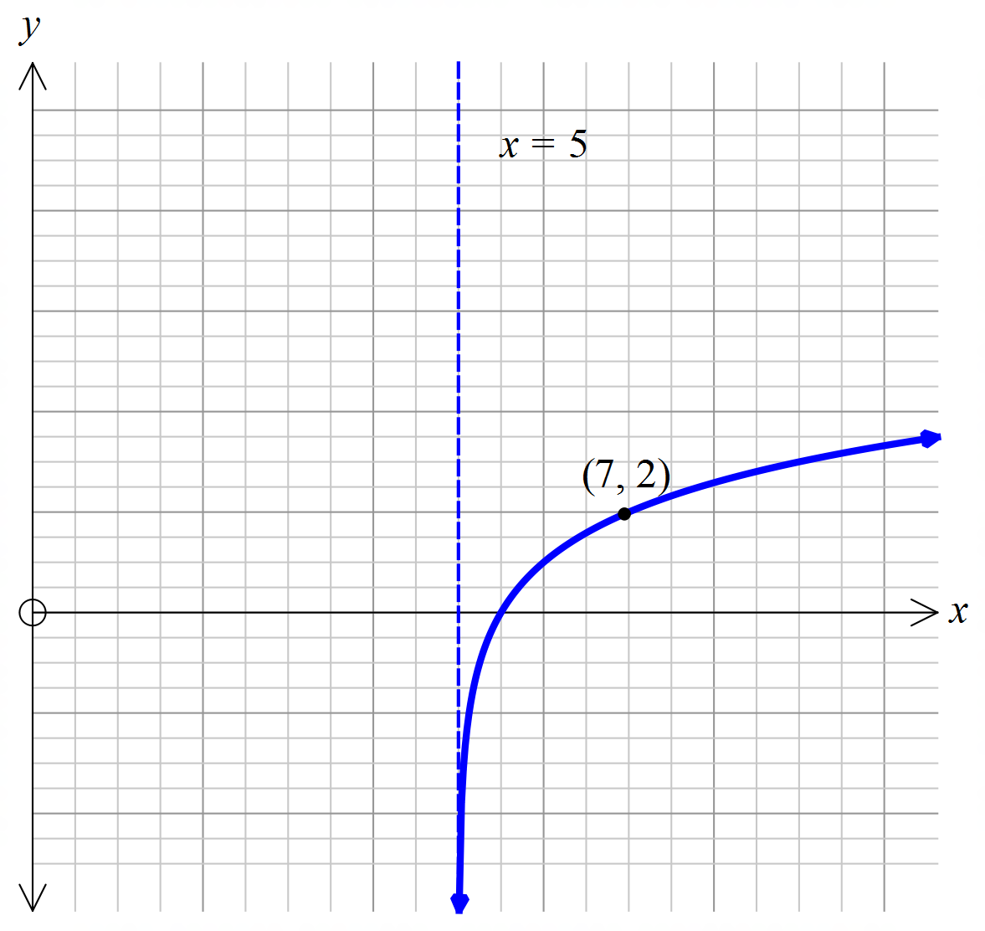

Find the values of $b$ and $c$.

|  |
| --- |
| **Solution** |
| *b* = 5 and *c* = 1 |
| **Specific behaviours** |
| ✓ correct *b*  ✓ correct *c* |

(b) Draw the graph of the function in the form $y=\log_{3}\left(x-b\right)+c$ which passes through the points (5, 10) and (-1, 9).

(3 marks)

|  |
| --- |
| **Solution** |
|  |
| **Specific behaviours** |
| ✓ correct asymptote shown  ✓ accurate sketch  ✓ arrows on sketch |

1. What are the values of $b$ and $c$?

|  |
| --- |
| **Solution** |
|  |
| **Specific behaviours** |
| ✓ correct *b*  ✓ correct *c* |

(2 marks)

1. State the domain and range of the function. (2 marks)

|  |
| --- |
| **Solution** |
|  |
| **Specific behaviours** |
| ✓ correct domain  ✓ correct range |

Question 19 (8 marks)

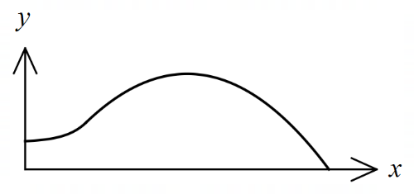The edges of a swimming pool design, when viewed  
from above, are the $x$-axis, the $y$-axis and the curves

$y=-0.1x^{2}+1.6x-1.5$ and $y=1.4+e^{x-3}$

where $x$ and $y$ are measured in metres.

(a) Determine the gradient of the curve at the point where the two curves meet.

(3 marks)

|  |
| --- |
| **Solution** |
| Curves intersect when $x=3$ $$y^{'}=-0.2\left(3\right)+1.6=e^{3-3}=1$$ |
| **Specific behaviours** |
| ✓ -coordinate of intersection  ✓ derivate of a function  ✓ correct gradient |

(b) Determine the surface area of the swimming pool. (4 marks)

|  |
| --- |
| **Solution** |
| $$A_{1}=\int_{0}^{3}{1.4+e^{x-3}}dx=\frac{26}{5}-\frac{1}{e^{3}}≈5.15$$ $$A_{2}=\int_{3}^{15}{-0.1x^{2}+1.6x-1.5}dx=\frac{216}{5}=43.2$$ $$A_{1}+A_{2}=\frac{242}{5}-\frac{1}{e^{3}}≈48.35 {\text{m}}^{2}$$ |
| **Specific behaviours** |
| ✓ upper bound for parabola  ✓ area $A_{1}$ ✓ area $A_{2}$ ✓ total area, with units |

(c) Given that the water in the pool has a uniform depth of $145$ cm, determine the capacity of the pool in kilolitres ( $1$ kilolitre of water occupies a volume of m3).

(1 mark)

|  |
| --- |
| **Solution** |
| $$C=48.35×1.45≈70.1 \text{kL}$$ |
| **Specific behaviours** |
| ✓ correct capacity |

Question 20 (6 marks)

The moment magnitude scale $M_{w}$ is used by seismologists to measure the size of earthquakes in terms of the energy released. It was developed to succeed the 1930's-era Richter magnitude scale.

The moment magnitude has no units and is defined as $M_{w}=\frac{2}{3}\log_{10}\left(M_{0}\right)-10.7$, where $M_{0}$ is the total amount of energy that is transformed during an earthquake, measured in dyn $∙$ cm.

(a) On 28 June 2016, an estimated $2.82×{10}^{21}$ dyn∙cm of energy was transformed during an earthquake near Norseman, WA. Calculate the moment magnitude for this earthquake.

(1 mark)

|  |
| --- |
| **Solution** |
| $$M_{w}=3.6$$ |
| **Specific behaviours** |
| ✓ calculates MM |

(b) A few days later, on 8 July 2016, there was another earthquake with moment magnitude 5.2 just north of Norseman. Calculate how much energy was transformed during this earthquake. (2 marks)

|  |
| --- |
| **Solution** |
| $$5.2=\frac{2}{3}\log_{10}{x}-10.7 \\ x=7.08×{10}^{23} \text{dyn}∙\text{cm}$$ |
| **Specific behaviours** |
| ✓ substitutes  ✓ solve for energy |

(c) Show that an increase of 2 on the moment magnitude scale corresponds to the transformation of 1000 times more energy during an earthquake. (3 marks)

|  |
| --- |
| **Solution** |
| $$M_{w}=\frac{2}{3}\log_{10}\left(x\right)-10.7…\left(1\right) \text{and }M_{w}+2=\frac{2}{3}\log_{10}\left(y\right)-10.7…(2)$$ $$\left(2\right)-\left(1\right):2=\frac{2}{3}(\log_{10}{y}-\log_{10}{x})$$ $$\log_{10}{\frac{y}{x}}=3$$ $$\frac{y}{x}={10}^{3}=1000 \text{times greater}$$ |
| **Specific behaviours** |
| ✓ writes two equations for $M$ and  ✓ combines the equations for comparison  ✓ rearranges equation to show correct answer  *NB Max ✓ if uses specific values rather than general case* |

Question 21 (8 marks)

Given that $f\left(-2\right)=-2, f^{'}\left(-2\right)=-1, g\left(-2\right)=4$ and $g^{'}\left(-2\right)=3$, evaluate $h'(-2)$ in each of the following cases.

(a) $h\left(x\right)={\left(f\left(x\right)\right)}^{5}$. (2 marks)

|  |
| --- |
| **Solution** |
| $$h^{'}\left(-2\right)=5×{\left(f\left(-2\right)\right)}^{4}×f'(-2) \\ =5×{(-2)}^{4}×(-1) \\ =-80$$ |
| **Specific behaviours** |
| ✓ uses chain rule  ✓ correct value |

(b) $h\left(x\right)=\begin{matrix}g(x) \\ \overline{f(x)}\end{matrix}$. (2 marks)

|  |
| --- |
| **Solution** |
| $$h^{'}\left(-2\right)=\frac{g^{'}\left(-2\right)×f\left(-2\right)-g\left(-2\right){×f}^{'}\left(-2\right)}{f{\left(-2\right)}^{2}} \\ =\frac{3×\left(-2\right)-4×\left(-1\right)}{{\left(-2\right)}^{2}} \\ =-\frac{1}{2}$$ |
| **Specific behaviours** |
| ✓ uses quotient rule  ✓ correct value |

(c) $h\left(x\right)=g\left(f\left(x\right)\right)$. (2 marks)

|  |
| --- |
| **Solution** |
| $$h^{'}\left(-2\right)=g^{'}\left(f\left(-2\right)\right)×f^{'}\left(-2\right) \\ =g^{'}\left(-2\right)×f^{'}\left(-2\right) \\ =3×(-1) \\ =-3$$ |
| **Specific behaviours** |
| ✓ uses chain rule  ✓ correct value |